If there was any celebrity in the mid-Twentieth Century who didn’t need to make even more money, it was Bing Crosby. Virtually everything he tried his hand at… music (43 № 1 hits, including the best-selling song of all time at 50 million copies sold, “White Christmas”)… movies (a string of box office smashes, and a Best Actor Oscar for “Going My Way,” the highest-grossing film of 1944)… radio (as one of the highest rated radio performers for some twenty years)… television (both owning several local stations, as well as producing such hit TV series as “Hogan’s Heroes” and “Ben Casey,” and hosting a string of annual Christmas variety specials)… sports (owning 25% of the Pittsburgh Pirates)… and even orange juice (as a principal investor in Minute Maid). And that’s not even including his successful ranching, thoroughbred horse breeding, and oil wells.
But perhaps his most unusual investment… and ultimately perhaps most lucrative… was in magnetic recording tape. The circumstances that first interested him in the experimental technology was not so much about making money, but rather making his life easier.
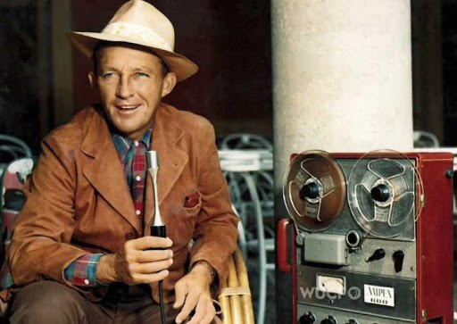

In the mid-1940s, Crosby was the star of “The Kraft Music Hall” (KMH), one of the highest-ranked shows on radio. Like virtually every other radio program, KMH was broadcast live (and not once, but twice… once for the East Coast and Midwest, and then once more for the West Coast). Each Thursday from afternoon until the evening, Crosby had to be at the NBC studio to rehearse and then broadcast the program (again, twice). Given his busy schedules making movies, recording music, and performing at military hospitals for wounded servicemen and at war bond rallies, having a fixed day and time to do the radio show often proved to be overly burdensome.
But from a friend in the U.S. Army and serving in Europe, he learned that American troops had seized German experiments in magnetic recording tape. At that time, sound recording was done directly to wax cylinders or to lacquer discs (recording to magnetic wire produced unsatisfactory results in most instances). Crosby had an epiphany: He could record KMH on tape at his own leisure, whenever he had free time during the week (and he could even record several weeks’ worth of episodes on a single day).
Unfortunately, the network refused, insisting that he do the show live. Crosby protested by walking off KMH for more than half-a-year, until finally a lawsuit from NBC forced him to return. However, as soon as his contract expired in 1946, Crosby jumped over to the rival Mutual radio network, which was willing to let him record his new program, “Philco Radio Time,” on tape.
But that was only half the battle. It wasn’t enough to simply get the network to let him record his program… he had to have the tape and the recording equipment to do so. Crosby invested heavily into research and development of magnetic tape and recorders, and the result was a quantum leap over what the Germans had been producing. It proved to be incredibly financially lucrative for Crosby, as it changed the face of recording technology for decades to come.
P.S. Bing made some micro-investments in recording technology as well. For instance, he financed his guitar player, Les Paul, in his experiments in both the solid-body electric guitar as well as the recording studio… both of which were integral to the rock and roll revolution to come. (From Gene Popa, Quora)

American audio engineer Jack Mullin was a member of the U.S. Army Signal Corps during World War II. His unit was assigned to investigate German radio and electronics activities, and in the course of his duties, a British Army counterpart mentioned the Magnetophons being used by the allied radio station in Bad Nauheim near Frankfurt. He acquired two Magnetophon recorders and 50 reels of I.G. Farben recording tape and shipped them home. Over the next two years, he worked to develop the machines for commercial use, hoping to interest the Hollywood film studios in using magnetic tape for movie soundtrack recording.
Mullin gave a demonstration of his recorders at MGM Studios in Hollywood in 1947, which led to a meeting with Bing Crosby, who immediately saw the potential of Mullin’s recorders to pre-record his radio shows. Crosby invested $50,000 in a local electronics company, Ampex, to enable Mullin to develop a commercial production model of the tape recorder. Using Mullin’s tape recorders, and with Mullin as his chief engineer, Crosby became the first American performer to master commercial recordings on tape and the first to regularly pre-record his radio programs on the medium.
Ampex and Mullin subsequently developed commercial stereo and multitrack audio recorders, based on the system originally invented by Ross Snyder of Ampex Corporation for their high-speed scientific instrument data recorders. Les Paul had been given one of the first Ampex Model 200 tape decks by Crosby in 1948, and ten years later ordered one of the first Ampex eight-track “Sel Sync” machines for multitracking. Ampex engineers, who included Ray Dolby on their staff at the time, went on to develop the first practical videotape recorders in the early 1950s to pre-record Crosby’s TV shows. (From Wikipedia)

